**Big Data Analytics Lab Learning Component-II 08-06-2021**

**Programming Exercise**

**Name: Sriranjan S**

**USN: 1NT18IS159**

**Exercise-I**

**Create a dataset in excel as a “.csv” file and it should contain the following fields with at least 20 sample datasets in it**

|  |  |  |  |  |  |
| --- | --- | --- | --- | --- | --- |
| Name | SSN | Salary | Awards | Tax paid | Eligible for Pay raise |
| Ajay | 61302 | 30000 | 2 | YES | YES |

**Use the Hadoop MapReduce programming framework to come up with a Program which will take the data from this .csv file and computes the following.**

1. Total number of employees who are eligible for the pay raise.
2. Total number of cumulative awards the company had this year.
3. How many total awards were obtained by the employee whose salary is 30000?
4. Count the number of employees who had paid the Tax.

**What is MapReduce?**

* MapReduce is a processing technique and a program model for distributed computing based on java. The MapReduce algorithm contains two important tasks, namely Map and Reduce. Map takes a set of data and converts it into another set of data, where individual elements are broken down into tuples (key/value pairs).
* Secondly, the reduce task takes the output from a map as an input and combines those data tuples into a smaller set of tuples. As the sequence of the name MapReduce implies, the reduce task is always performed after the map job.
* Once we write an application in the MapReduce form, scaling the application to run over hundreds, thousands, or even tens of thousands of machines in a cluster is merely a configuration change. This simple scalability is what has attracted many programmers to use the MapReduce model.

**Click on “Dataset” to access:** [**Dataset**](https://github.com/1NT18IS159/1NT18IS159_sriranjan_B_bdLab/blob/main/data.csv)

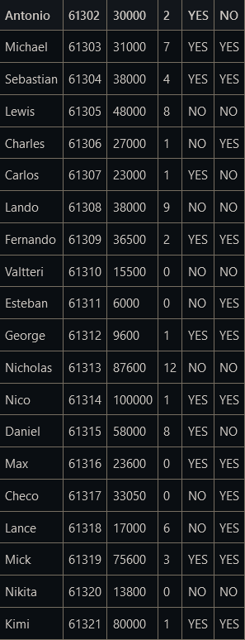

**Answers:**

1. **Compute total number of employees who are eligible for the pay raise**

**Code:** [**Pay Raise**](https://github.com/1NT18IS159/1NT18IS159_sriranjan_B_bdLab/blob/main/Program1.java)

* hdfs dfs -put ~/Documents/BDLA2/data.csv ~/input/
* hadoop jar /home/hadoop/PayRaise.jar ~/input ~/out1
* hdfs dfs -ls ~/out1
* hdfs dfs -cat ~/out1/part-00000

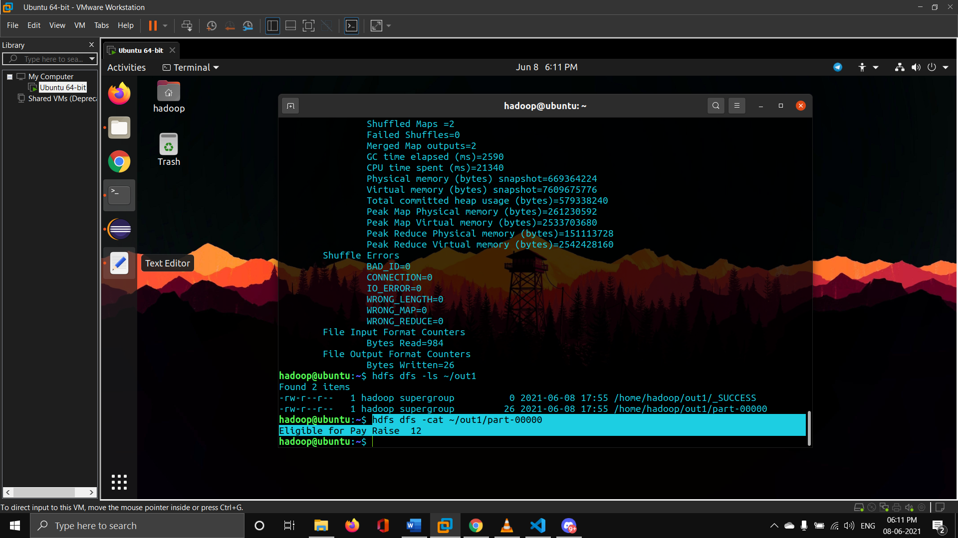

1. **Compute total number of cumulative awards the company had this year**

**Code:** [**Cumulative Awards**](https://github.com/1NT18IS159/1NT18IS159_sriranjan_B_bdLab/blob/main/Program2.java)

* sudo su - hadoop
* hdfs dfs -mkdir -p bdlab
* hdfs dfs -put /home/hadoop/Desktop/data.csv ~/bdlab
* hdfs dfs -rm ~/input/data.csv
* hdfs dfs -rmdir ~/input
* hadoop jar /home/hadoop/cumAwards.jar ~/input ~/out222
* hdfs dfs -ls ~/out222
* hdfs dfs -cat ~/out222/part-00000

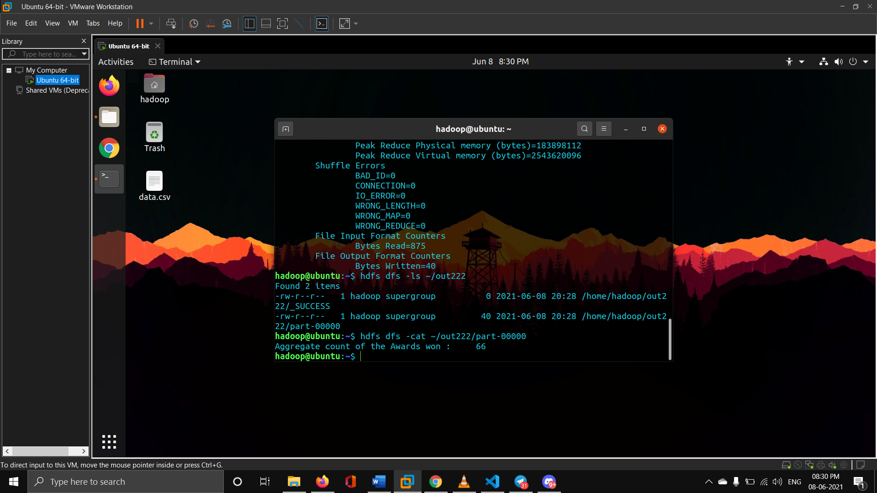

1. **How many total awards were obtained by the employee whose salary is 30000?**

**Code:** [**Salary Is Thirty Thousand**](https://github.com/1NT18IS159/1NT18IS159_sriranjan_B_bdLab/blob/main/Program3.java)

* hadoop jar /home/hadoop/equalTo30.jar ~/input ~/out3
* hdfs dfs -cat ~/out3/part-00000

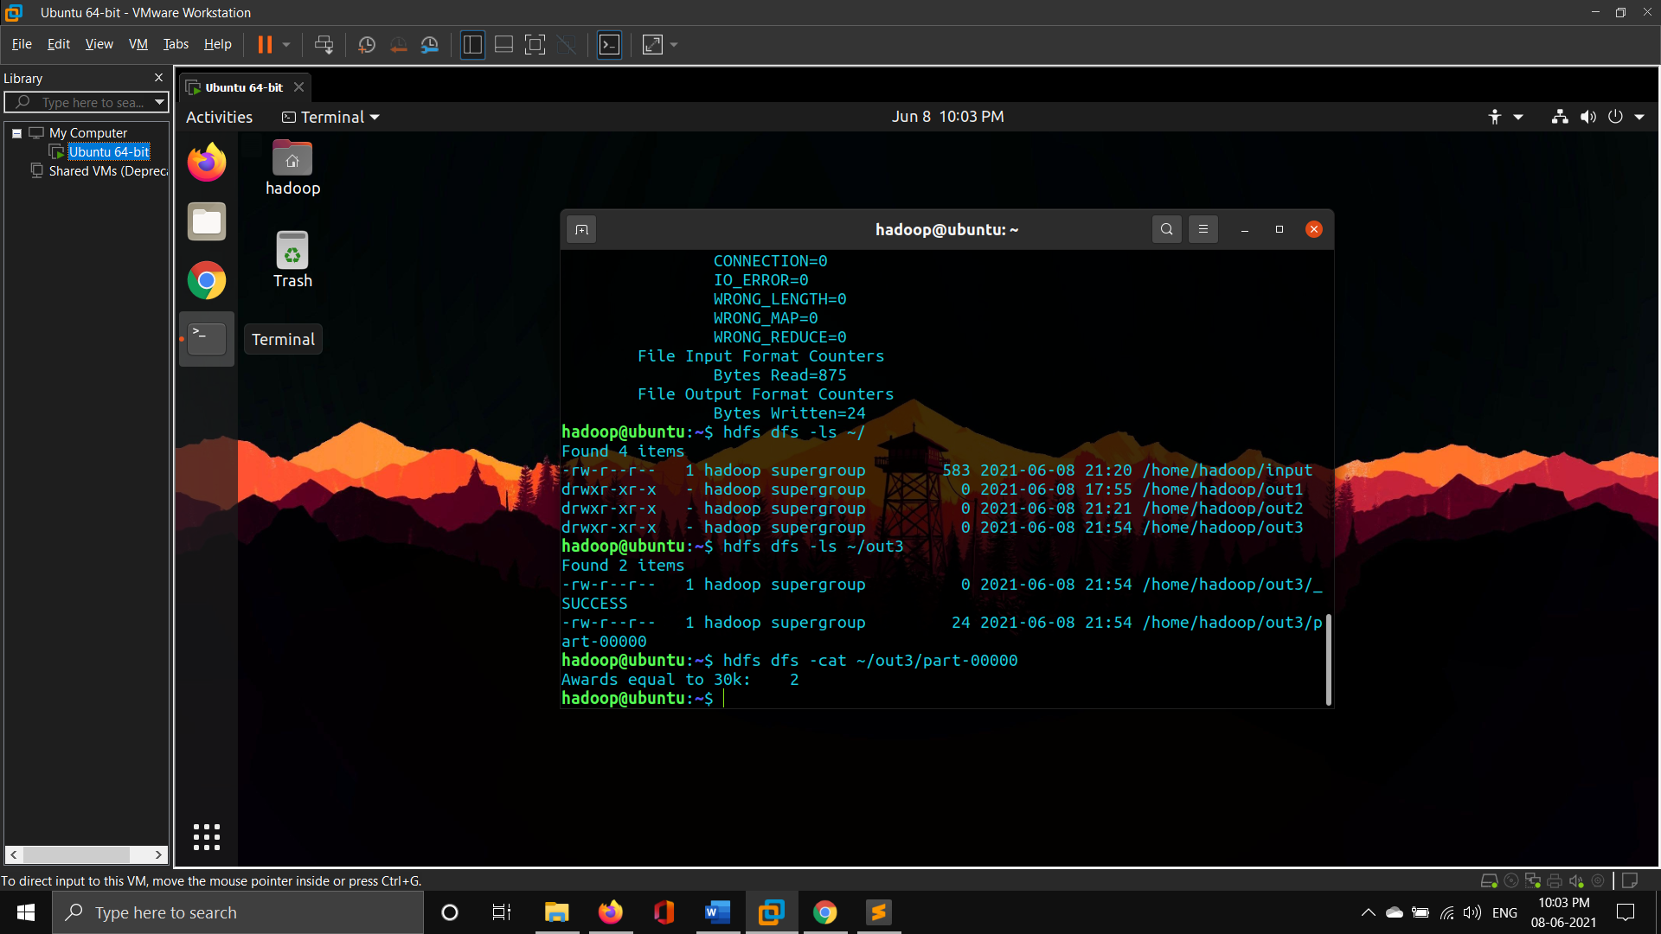

1. **Count the number of employees who had paid the Tax**

**Code:** [**Tax Paid**](https://github.com/1NT18IS159/1NT18IS159_sriranjan_B_bdLab/blob/main/Program4.java)

* hadoop jar /home/hadoop/TaxPaid.jar ~/input ~/out4
* hdfs dfs -ls ~/out4
* hdfs dfs -cat ~/out4/part-00000

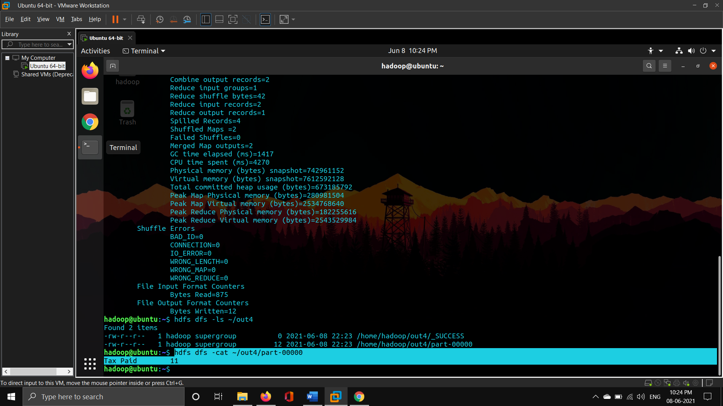

**Exercise-II**

**Use the above dataset in a .csv file and create a database called EmployeeDB. Create a table under the database called as Employee using HIVEQL. The table fields are same, that is**

|  |  |  |  |  |  |
| --- | --- | --- | --- | --- | --- |
| Name | SSN | Salary | Awards | Tax paid | Eligible for Pay raise |
| Ajay | 61302 | 30000 | 2 | YES | YES |

**Use the HiveQL language to perform the following Query based Map-reduce operations:**

1. Insert 5 records using the INSERT command
2. Demonstrate the Alter command for the following cases

* Rename the table name to “Emp”
* Rename the column name “Eligible for Pay raise” to “Eligibility”.

1. Count the number of Employees who are eligible for pay raise who had paid the tax.
2. Extract all the users ordered by the Name who had paid the tax but are not eligible for pay raise.
3. Create a separate view containing “SSN and Salary” and call the view as sal_ssn_view.
4. Display (name, eligibility) fields grouped by the SSN.
5. Display the (Name, SSN) of employees whose salary is >40000 but < 48000.
6. Create Another table called orders with the following fields (custssn = SSN in the Employee) and perform the following joins (outer, left outer, right outer) over custssn

|  |  |  |
| --- | --- | --- |
| **orderid** | **custssn** | **Amount** |
| **63** | **61302** | **50000** |

**Queries performed:** [**HIVE QUERIES**](https://github.com/1NT18IS159/1NT18IS159_sriranjan_B_bdLab/blob/main/HIVE%20Queries%20LA2.txt)

**Click on “Dataset” to access:** [**Dataset**](https://github.com/1NT18IS159/1NT18IS159_sriranjan_B_bdLab/blob/main/data.csv)



**Answers:**

**Prerequisites creation of db, tables and loading of data.csv**

* sudo su - hadoop
* echo $HIVE_HOME
* echo $PATH
* jps
* hive
* create database EmployeeDB;
* use EmployeeDB;
* create table Employee(Name string,SSN int,Salary int,Awards int,TaxPaid

> string,Eligibleforraise string)

> row format delimited

> fields terminated by ",";

* LOAD DATA local INPATH "/home/hadoop/Desktop/data.csv" into table Employee;

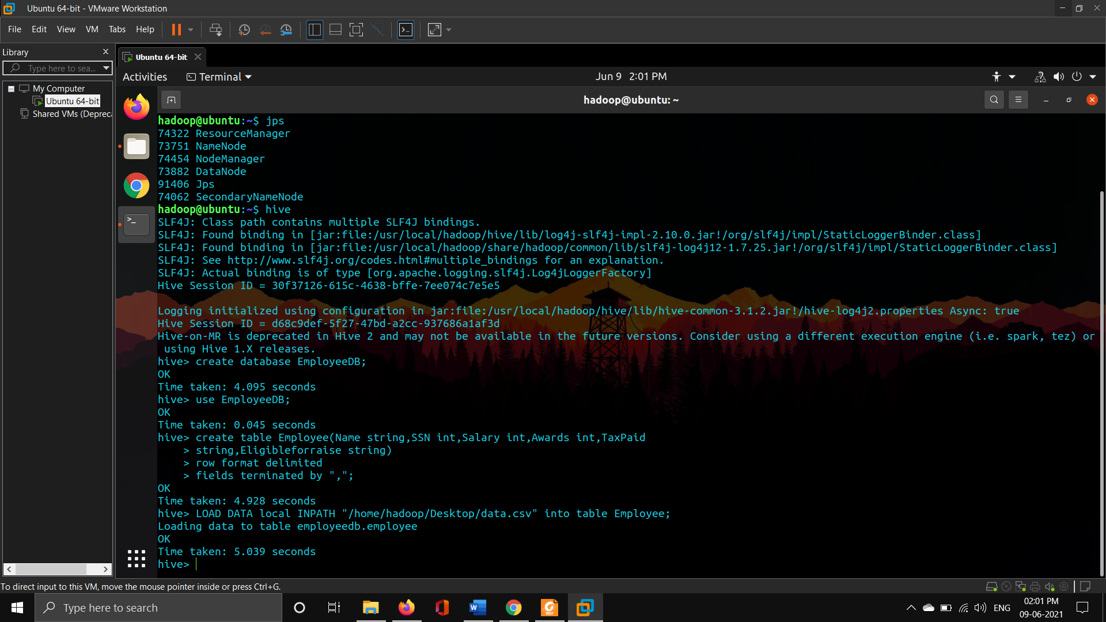

1. **Insert 5 records using the INSERT command**

* insert into Employee values

> ("James",787345, 93214, 1, "NO", "YES");

> ("Nikki", 63296, 98058, 2, "YES","NO"),

> ("Jos", 63297,12600, 1, "NO","NO"),

> ("Alain", 63298, 6300, 4, "NO","YES"),

> ("Ayrton", 63299, 41700, 3, "YES","YES");

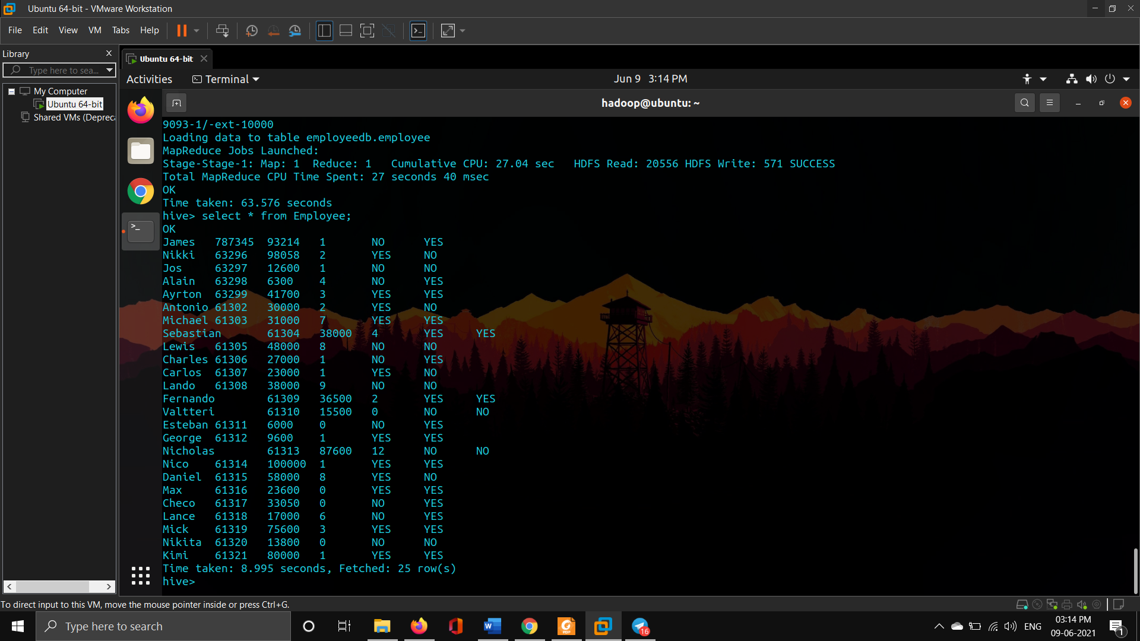

1. **Demonstrate the Alter command for the following cases**

* **Rename the table name to “Emp”**
* **Rename the column name “Eligible for Pay raise” to “Eligibility”**
* ALTER TABLE Employee RENAME TO Emp;

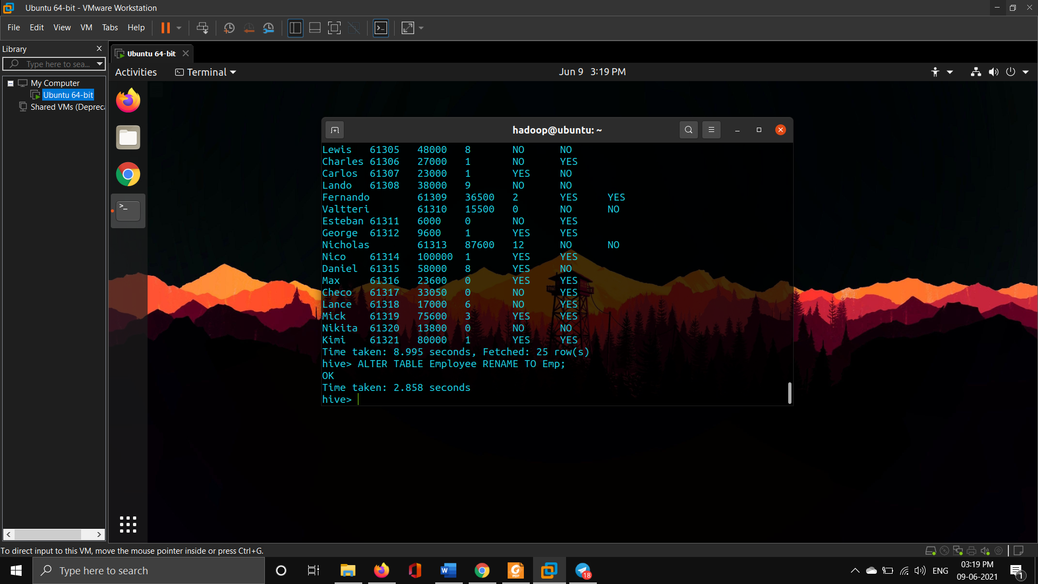

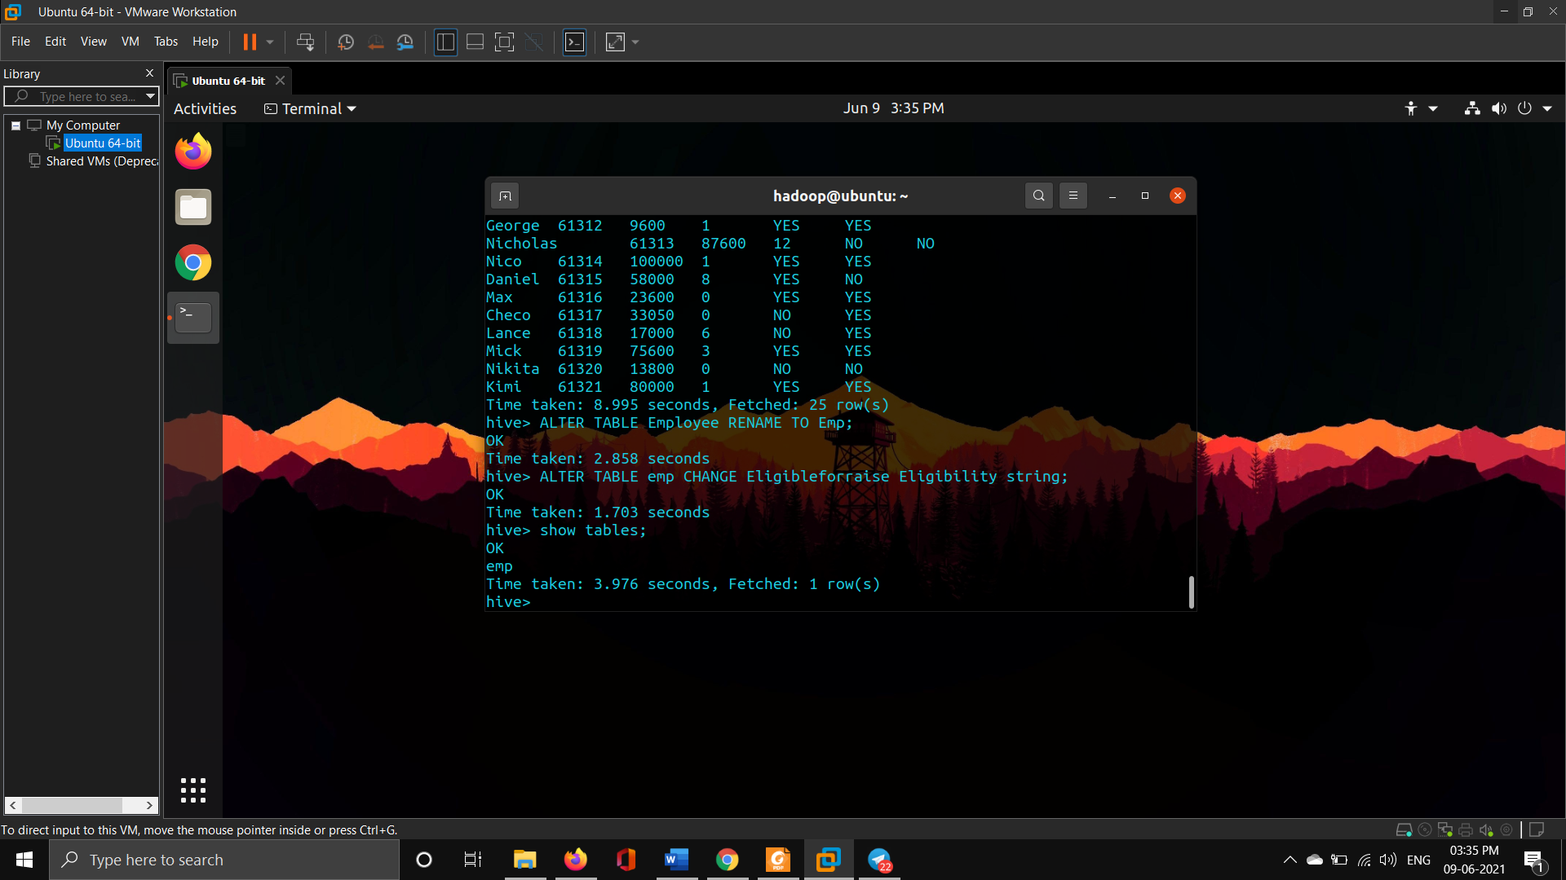

* ALTER TABLE emp CHANGE Eligibleforraise Eligibility string;

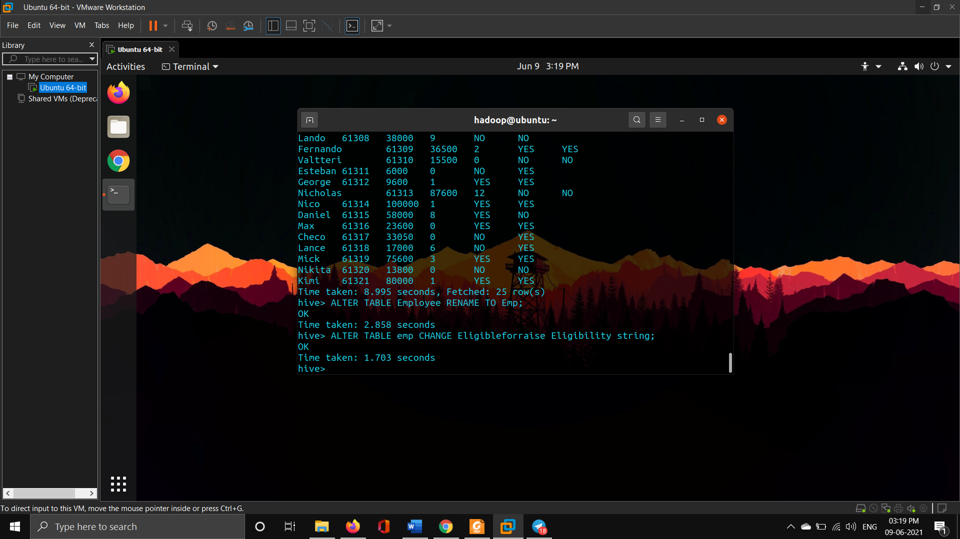

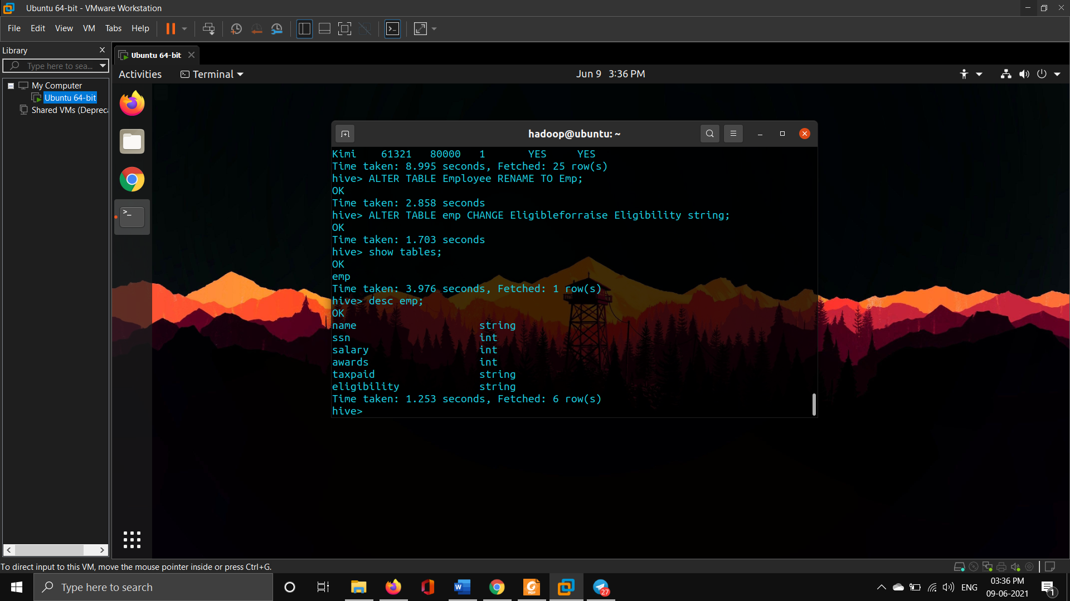

1. **Count the number of Employees who are eligible for pay raise who had paid the tax**

* select count(*)

> from emp

> where eligibility="YES" and taxpaid="YES";

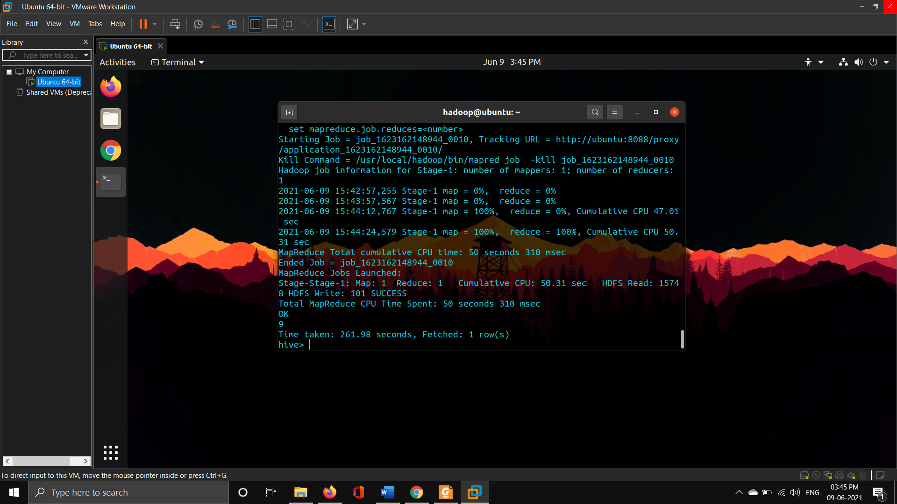

1. **Extract all the users ordered by the Name who had paid the tax but are not eligible for pay raise**

* select (name)

> from emp

> where taxpaid="YES" and eligibility="NO"

> order by name;

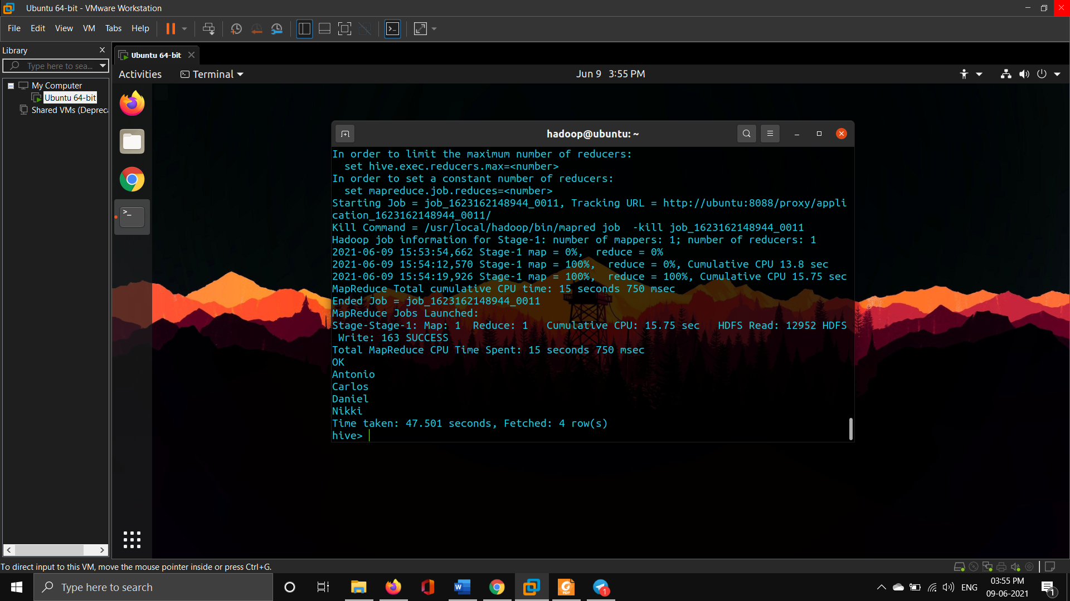

1. **Create a separate view containing “SSN and Salary” and call the view as sal_ssn_view**

* create view sal_ssn_view as

> select ssn,salary from emp;

* select * from sal_ssn_view;



1. **Display (name, eligibility) fields grouped by the SSN**

* select ssn, name, eligibility

> from emp

> group by ssn, name, eligibility;

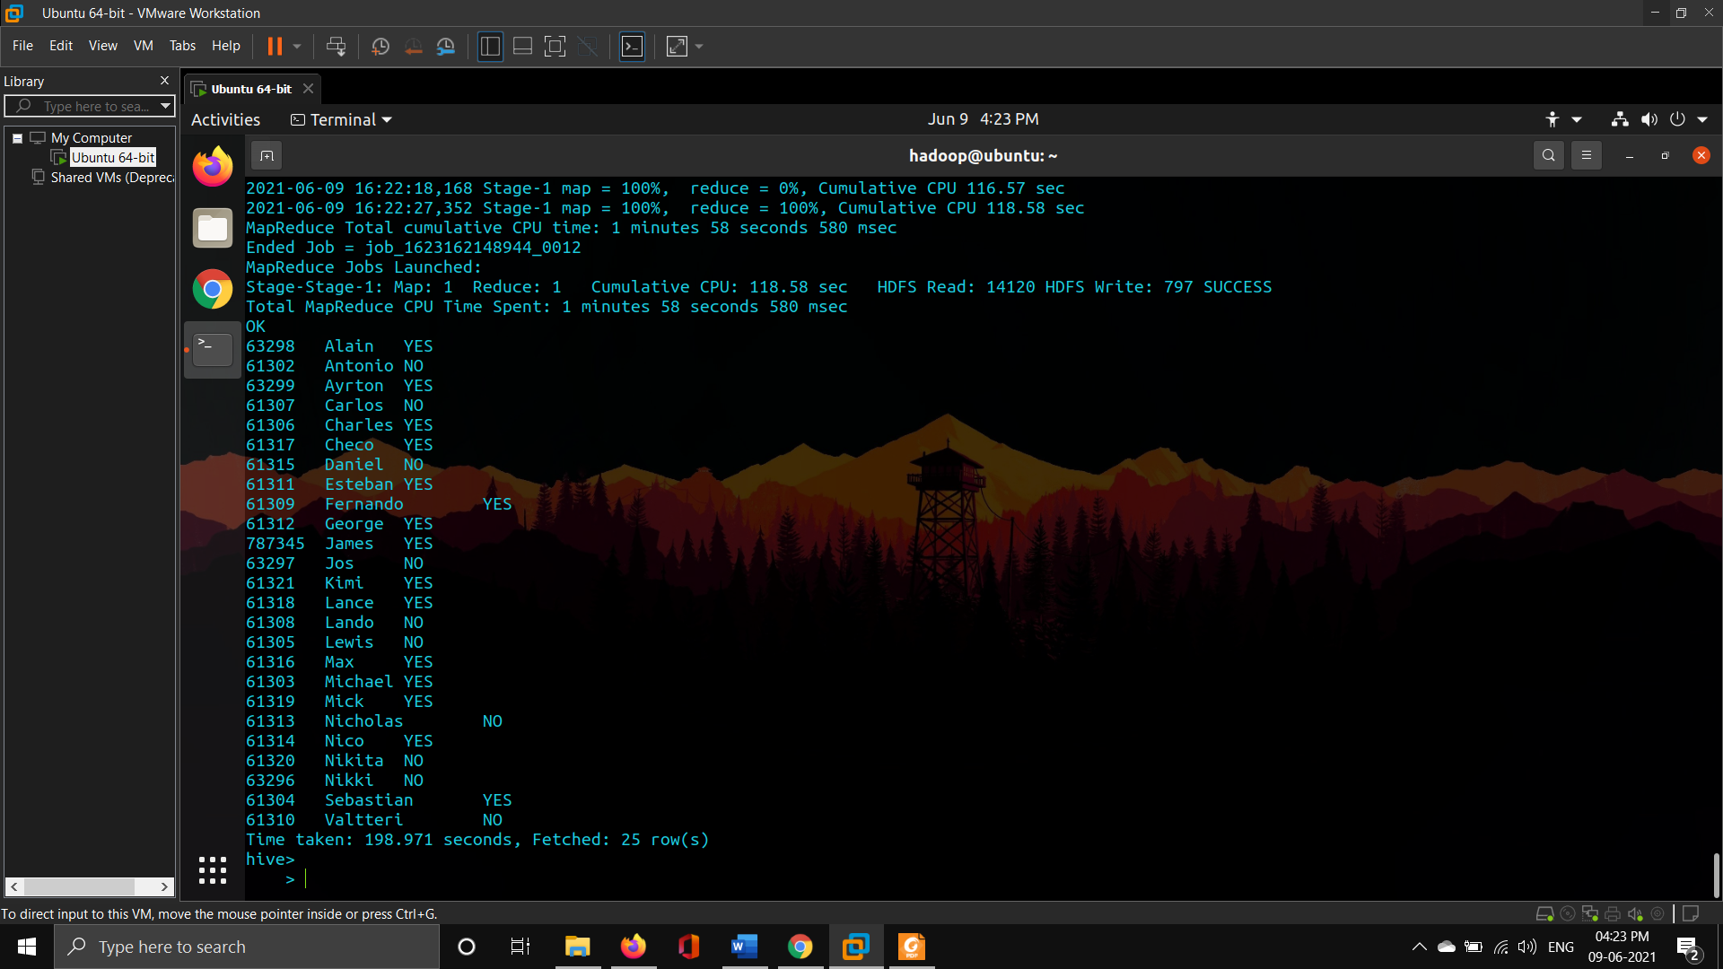

1. **Display the (Name, SSN) of employees whose salary is >40000 but < 48000**

* select name,ssn

> from emp

> where salary between 40000 and 48000;

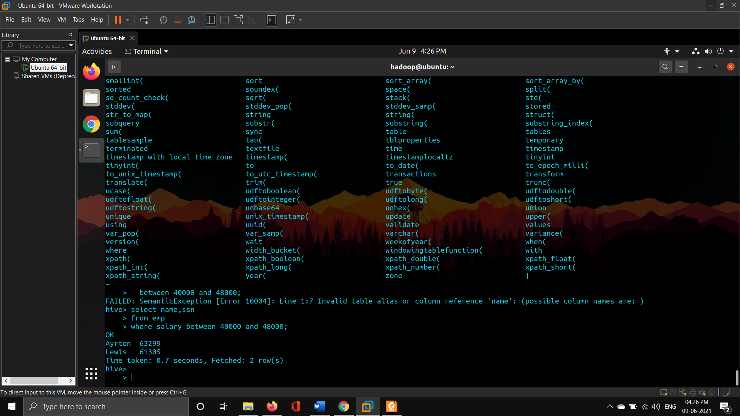

1. **Create Another table called orders with the following fields (custssn = SSN in the Employee) and perform the following joins (outer, left outer, right outer) over custssn**

|  |  |  |
| --- | --- | --- |
| **orderid** | **custssn** | **Amount** |
| **63** | **61302** | **50000** |

1. **Create table orders**

* create table orders (orderid int, custssn int, Amount int)

> row format delimited

> fields terminated by ",";

1. **Insert single row into orders**

* insert into orders

> values (63,61302,50000);



1. **Left Outer Join**

* select o.orderid, e.ssn, e.name, o.amount

> from emp e

> LEFT OUTER JOIN orders o

> ON (e.ssn = o.custssn);

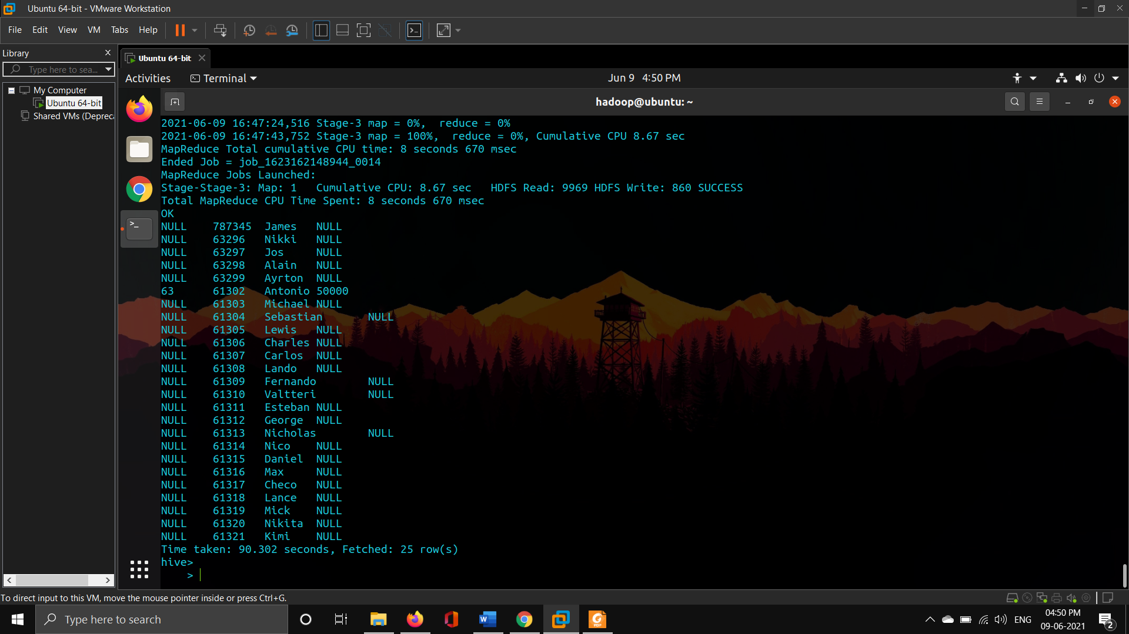

1. **Right Outer Join**

* select o.orderid, e.ssn, e.name, o.amount

> from emp e

> RIGHT OUTER JOIN orders o

> ON (e.ssn = o.custssn);

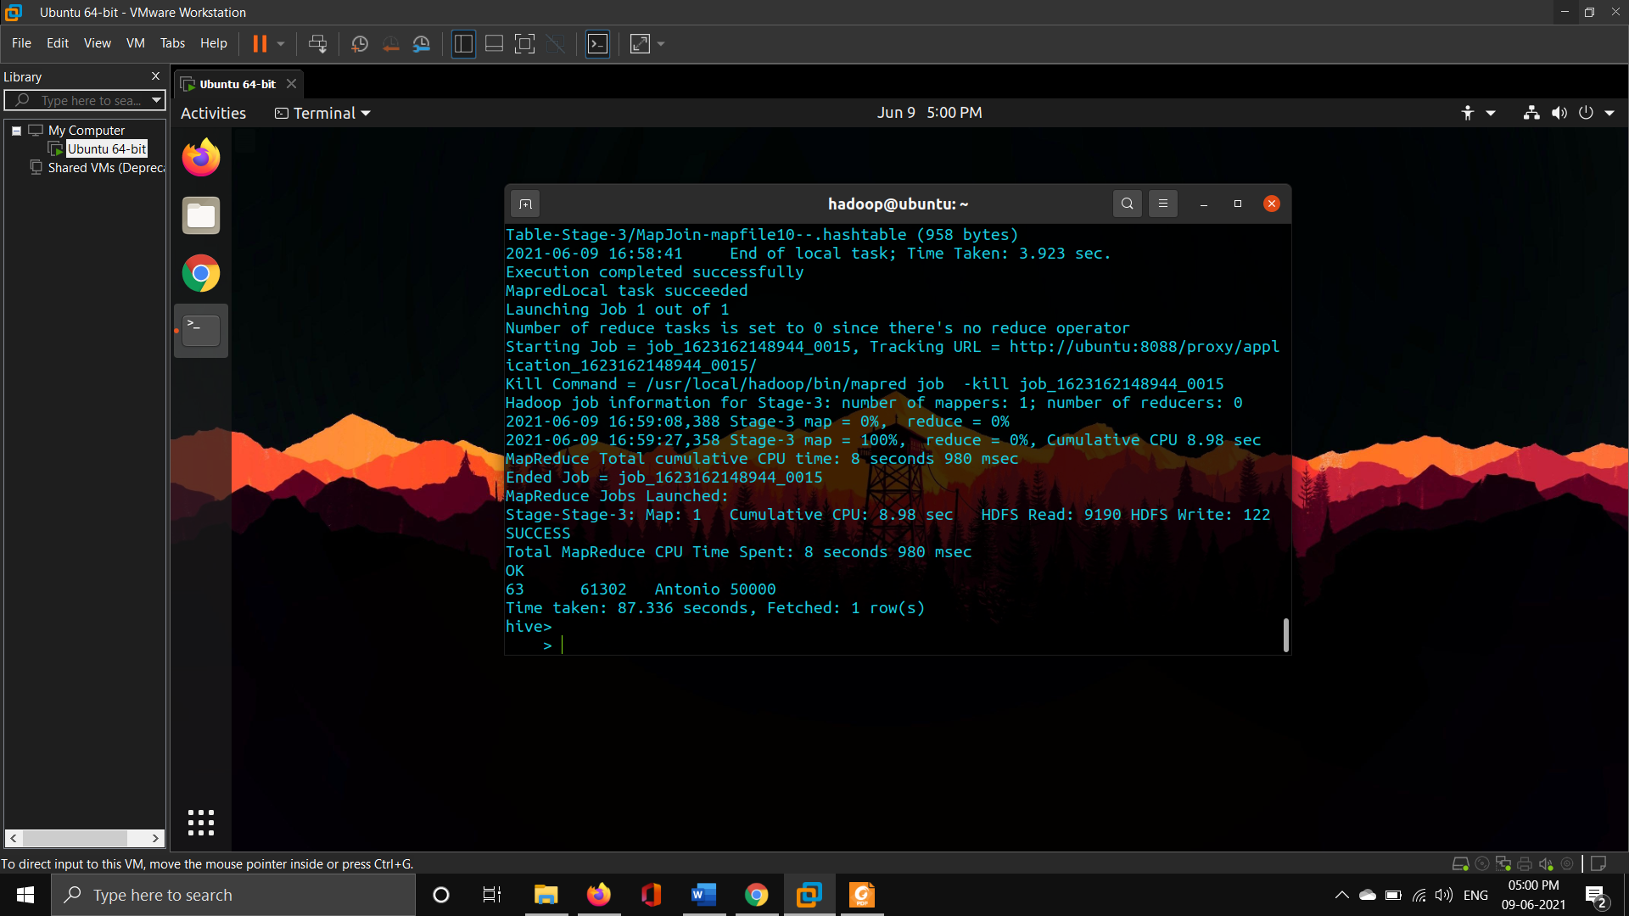

1. **Outer Join**

* select o.orderid, e.ssn, e.name, o.amount

> from emp e

> FULL OUTER JOIN orders o

> ON (e.ssn = o.custssn);

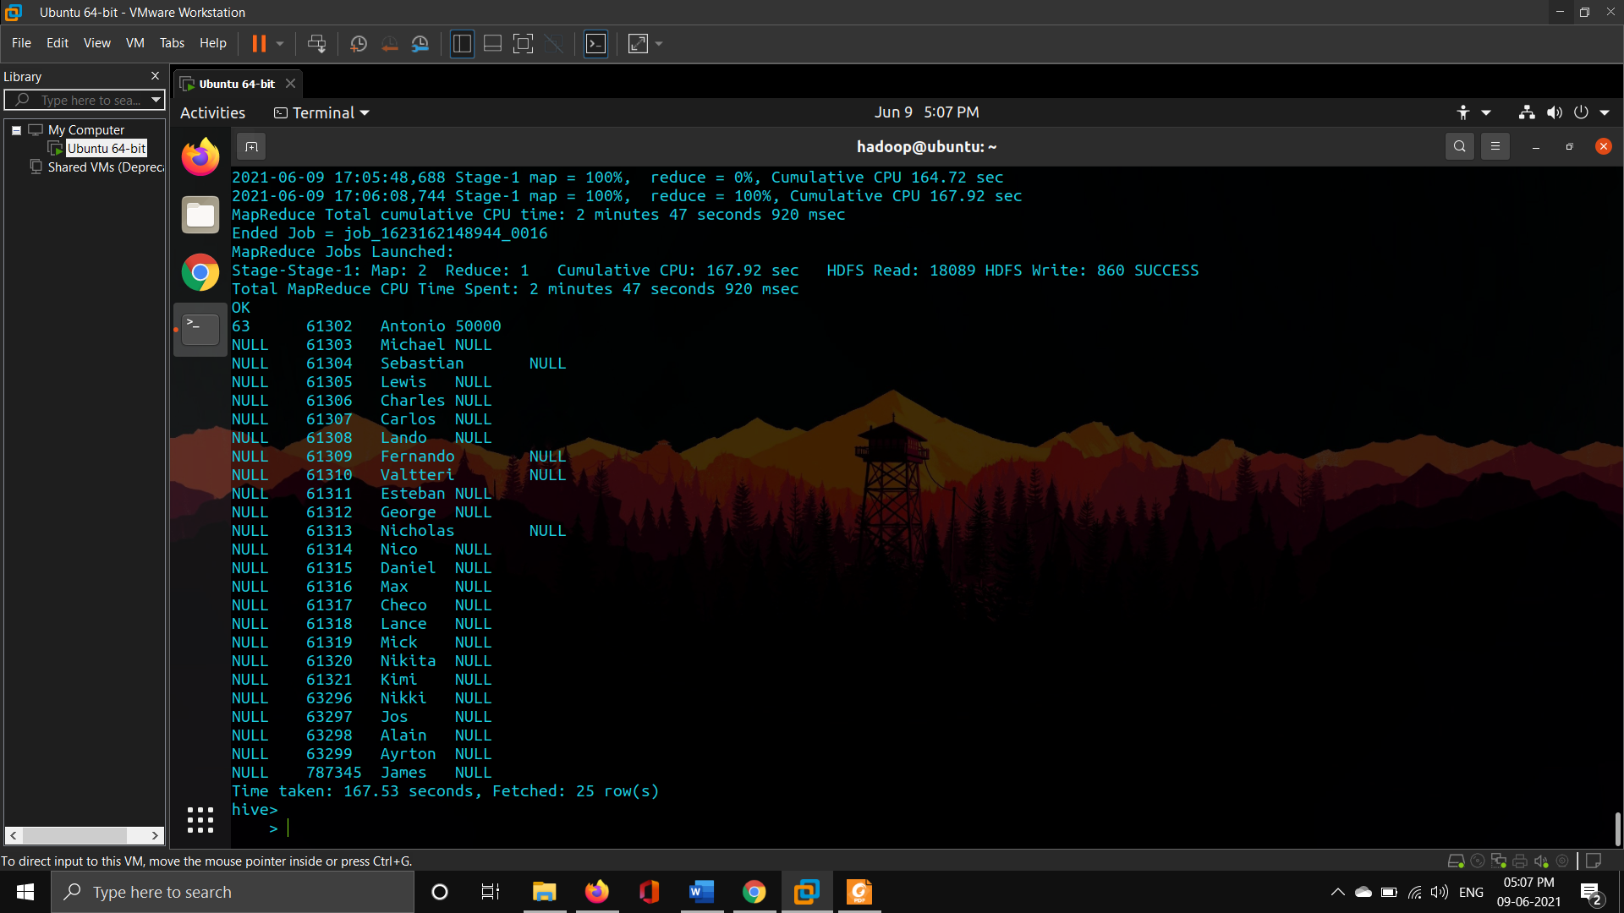

**Click on my USN to access my git repo containing all the assignments and lab session file**

**Sriranjan S**

[**1NT18IS159**](https://github.com/1NT18IS159/1NT18IS159_sriranjan_B_bdLab)